**Project Report**



2014-MC-21

2014-MC-23

2014-MC-24

2014-MC-25

2014-MC-46

## **Instant geyser**

### **Introduction**

Traditional geysers have to be manually turned on to heat up the water. In an instant geyser, when the water tap is opened, the burner turns on automatically and heats up the incoming water.

### **Objectives**

* To automate the traditional geyser
* To maintain the temperature of water in controlled levels

#### **Components**

* Solenoid actuated gas valve
* Flame Sensor
* Igniter
* Resistances
* Relay 24V DC
* Temperature switch
* 7805 IC
* Opto-coupler (TLP 521)
* Water Tap
* Copper pipe
* Tang Container
* Flow sensor

### **Method**

Water is filled up in the tank. When the water tap is turned on, water flows out of the valve which is sensed by the flow sensor and this information is sent to the PLC which sends the signal to turn on the gas valve and igniter. Both the gas valve and igniter are turned on for 15 seconds till a flame is ignited which is sensed with the help of a flame sensor. If the flame sensor does not sense any flame within these 15 seconds then it sends a signal to the PLC that there is an error in the igniter or the gas valve. If the temperature of the water rises above 80℃, then the temperature switch is triggered, which sends a signal to the PLC to shut off the gas valve so that the incoming water does not turn into steam.

### **Tools Required**

* Monkey Wrench
* Adjustable Spanner
* Screw drivers
* Hammer
* Pipe bender
* Thread and seal tape
* Pliers
* Grip and lever pliers
* Hole Saw
* Thimble plier
* Spirit level
* Hand Saw
* Hot glue gun
* Drill machine
* Jigsaw wood cutter
* Solder
* Power supply
* Laptop with Rslogix software installed.
* DMM

### **Results**

A prototype of instant geyser was created which worked as desired with the specified safety precautions.

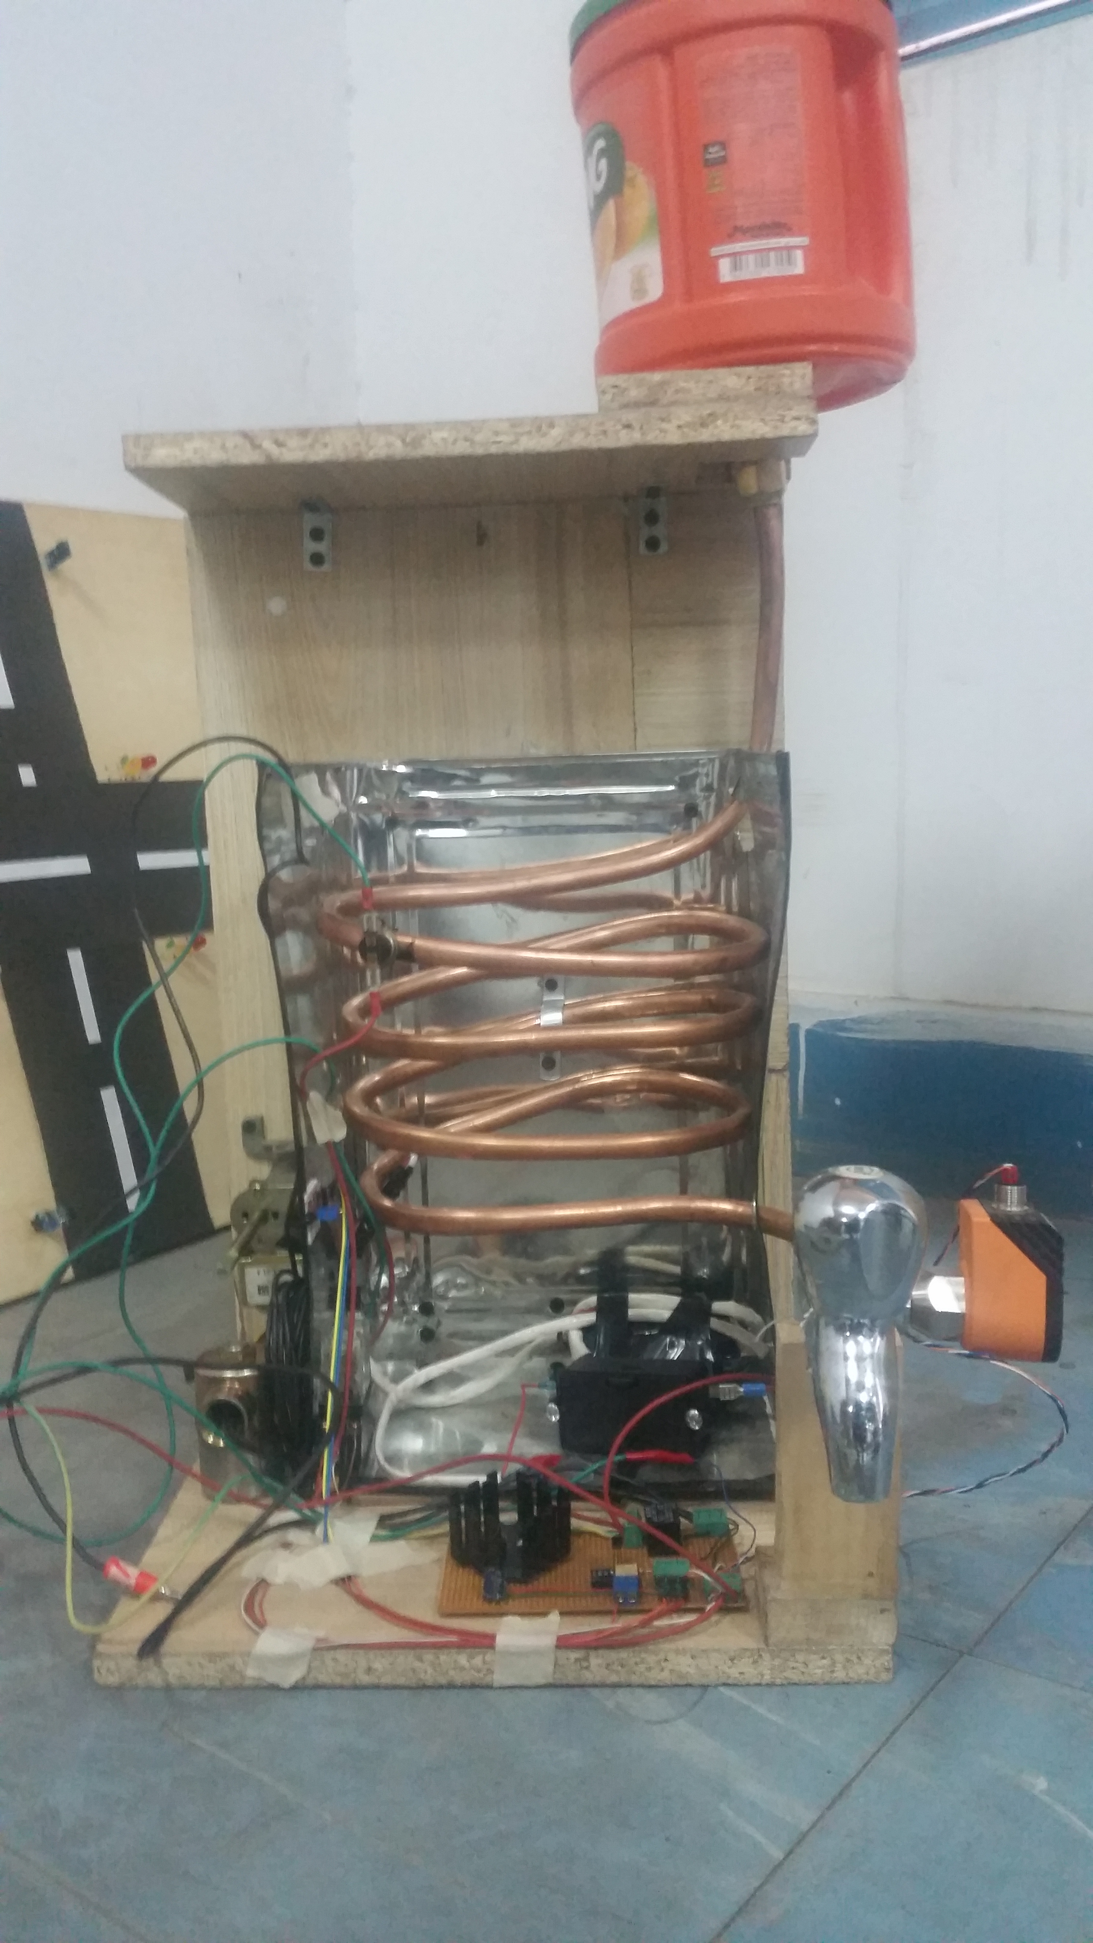

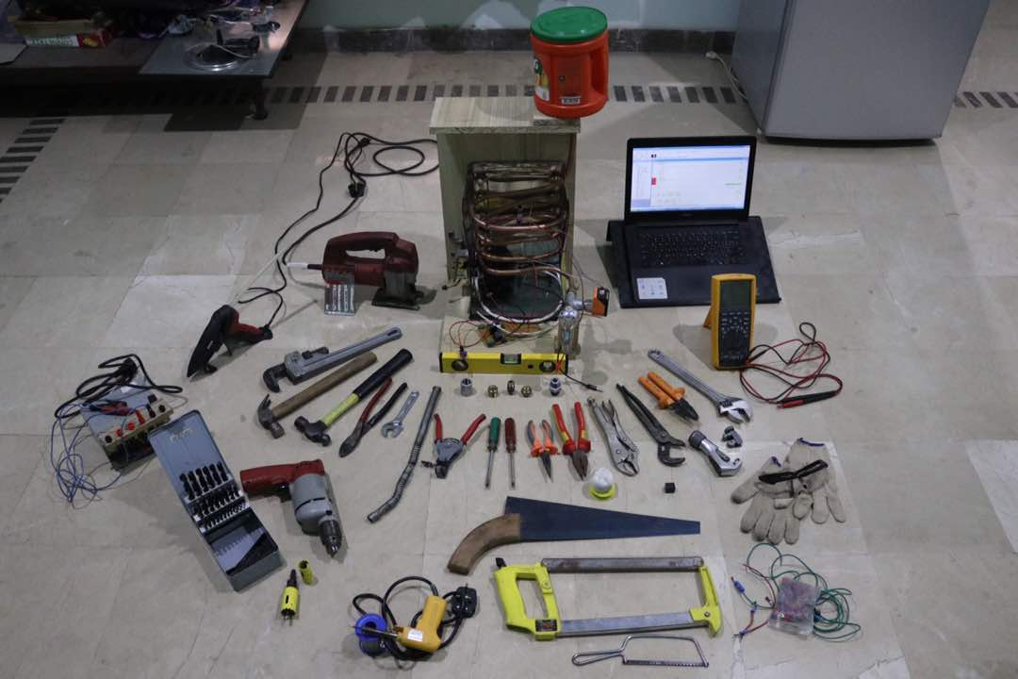

# Appendix

1. Ladder diagram.
2. Rslogix report.
3. Pictures